**SYNTHESIS OF SILVER NANOPARTICLES USING PHYLLANTHUS AMARUS AND EVALUATION OF THEIR CATALYTIC ACTIVITY ON REDUCTION OF METHYLENE BLUE**

**A PROJECT REPORT**

**Submitted by**

**V.ABHINAYA (312212203001)**

**M.MATHIVATHANI (312212203024)**

**In partial fulfillment for the award of the degree**

**Of**

**BACHELOR OF TECHNOLOGY**

**IN**

**CHEMICAL ENGINEERING**



**SRI SIVASUBRAMANIYA NADAR COLLEGE OF ENGINEERING**

**ANNA UNIVERSITY: CHENNAI 600025**,

**APRIL 2016**

**ANNA UNIVERSITY: CHENNAI 600025**

**BONAFIDE CERTIFICATE**

Certified that this project report “**Synthesis of silver nanoparticles using *Phyllanthus emblica* and evaluation of their catalytic activity on reduction of Methylene Blue”** is the bonafide work of **V.ABHINAYA (312212203001)** and **M.MATHIVATHANI (312212203024)** who carried out the project work under my supervision.

**Dr.R.PARTHIBAN**

HEAD OF DEPARTMENT,

PROFESSOR

Department of Chemical Engineering

SSN College of Engineering,

Kalavakkam,

Chennai-603110

Tamilnadu, India

**Dr.D.GNANAPRAKASH**

SUPERVISOR,

PROFESSOR

Department of Chemical Engineering

SSN College of Engineering, Kalavakkam

Chennai-603110

Tamilnadu, India

Submitted for the University Project Viva-voce held at Sri SivaSubramaniya Nadar College of Engineering on

**INTERNAL EXAMINER EXTERNAL EXAMINER**

**ACKNOWLEDGEMENT**

We are honoured to acknowledge the below mentioned people who were instrumental in the completion of the project. We extend our heartiest thanks to our parents and friends without whom this project would not have been possible.

We express our deep respect to Padma Bhushan Shri. **SHIV NADAR** chairman, SSN Institutions and **Ms.KALA VIJAYKUMAR**, President, SSN Institutions for working on a great mission and vision and providing excellent infrastructure. Our principal, **Dr.S.SALIVAHANAN** supported us a lot in our work.

We thank our head of the department, **DR.R.PARTHIBAN**, for his unceasing support and encouragement. Our heartfelt thanks to our guide, **DR.D.GNANAPRAKASH** for his patience and valuable guidance throughout our project.

We would like to thank **MR.K.RAJASEKARAN** for extending their helping hands to support us throughout the project. All these people helped us complete our project successfully on time.

**ABSTRACT**

A novel green approach for the synthesis of silver nanoparticles (AgNPs) using water extract of ***Phyllanthus emblica*** (P. emblica) under ambient conditions is reported in this article. The instant formation of AgNPs was analyzed by visual observation and UV–visible spectrophotometer. Further the effect of concentration of AgNO3 on the formation of AgNPs was also studied. The synthesized AgNPs were characterized by SEM. Appearance of brownish yellow color confirmed the formation of AgNPs. SEM revealed that the diameter of stable AgNPs was approximately 50 nm. Moreover the catalytic activity of synthesized AgNPs in the reduction Methylene blue dye was studied by UV–visible spectrophotometer. The synthesized AgNPs are observed to have a good catalytic activity on the reduction of methylene blue by P. emblica which is confirmed by the decrease in absorbance values of methylene blue with respect to time using UV–visible spectrophotometer.

**TABLE OF CONTENTS**

|  |  |  |
| --- | --- | --- |
| **Sno** | **Title** | **Page No** |
| (i) | Bonafide Certificate |  |
| (ii) | Acknowledgement |  |
| (iii) | Abstract |  |
| (iv) | List of tables |  |
| (v) | List of figures |  |
| (vi) | List of symbols |  |

|  |  |  |
| --- | --- | --- |
| **Sno** | **Contents** | **Page No** |
| 1 | Introduction |  |
| 1.1 | Chemical and physical synthesis of Silver nanoparticles |  |
| 1.2 | Biological synthesis of silver nanoparticles |  |
| 1.2.1 | Silver sysnthesizing plants |  |
| 1.2.2 | Phyllanthus emblica |  |
| 1.2.2.1 | Botanical description |  |
| 1.2.2.2 | Chemical composition |  |
| 1.3 | Applications of silver nanoparticles |  |
| 1.4 | Methylene Blue |  |
| 1.4.1 | Uses |  |
| 1.4.2 | Toxicity |  |
| 2 | Literature survey |  |
| 3 | Experimental work |  |
| 3.1 | Materials required |  |
| 3.1.1 | Silver nitrate |  |
| 3.1.2 | Methylene Blue |  |
| 3.2 | Methodology |  |
| 3.2.1 | Preparation of extract |  |
| 3.2.2 | Synthesis of silver nanoparticles |  |
| 3.3 | Total Phenolic content (TPC) |  |
| 3.4 | Analysis |  |
| 3.4.1 | UV- Visible spectroscopy characterization of AgNPs |  |
| 3.4.2 | Scanned Electron Microscopy (SEM) |  |
| 3.5 | Evaluation of effect of synthesized AgNPs on the reduction of Methylene Blue by Phyllanthus emblica extract |  |
| 4 | Results and discussion |  |
| 4.1 | Results |  |
| 4.2 | Synthesis of silver nanoparticles by green synthesis process |  |
| 4.3 | UV- Visible spectroscopy characterization |  |
| 4.4 | Total Phenolic content (TPC) |  |
| 4.5 | Mechanism of reduction of AgNO3 to AgNPs by the phyto constituents of phyllanthus emblica |  |
| 4.6 | Optimization of silver nitrate concentration in the synthesis of silver nanoparticles |  |
| 4.7 | Catalytic activity of synthesized AgNPs on the reduction of Methylene Blue by Phyllanthus emblica |  |
| 4.8 | Scanned Electron Microscopy (SEM) analysis |  |
| 5 | Design of instruments |  |
| 6 | Conclusion |  |
| 7 | References |  |

**LIST OF TABLES**

**TABLE NO. TABLES PAGE NO.**

TABLE 4.6.1 Variation of absorbance 27 with AgNO3 concentration

TABLE 4.7.1 Change in absorbance of Methylene 29

Blue dye

**LIST OF FIGURES**

|  |  |  |
| --- | --- | --- |
| **FIGURE NO.**  Fig. 3.1.1.1 | **FIGURES**  Structure of Silver Nitrate | **PAGE NO.**  15 |
| Fig.3.1.2.1 | Structure of Methylene Blue | 16 |
| Fig. 3.2.2.1 | Plant extract | 17 |
| Fig.3.5.1 | Effect of varying AgNO3 concentration on synthesis of AgNPs | 19 |
| Fig.3.6 | Reduction of Methylene Blue dye | 21 |
| Fig. 4.2.1 | Extract after the addition of AgNO3 | 22 |
| Fig 4.3.1 | Figure showing Absorption spectra of | 24 |
|  | AgNPs obtained from pulp with λmax at |  |
|  | 430 nm |  |
| Fig.4.6.2 | UV-Visible spectra of AgNPs showing | 27 |
|  | effect of concentration of AgNO3 |  |
| Fig 4.7.1 | UV-Visible Spectra of reaction | 29 |
|  | mixtures containing Methylene blue; |  |
|  |  |  |
| Fig.4.8.1 | SEM images of silver nanoparticles |  |
|  |  |  |
|  |  |  |
|  |  |  |

**LIST OF SYMBOLS**

AgNO3 Silver Nitrate

AgNP Silver Nanoparticles

Λ Wavelength

µ Micro

NaBH4 Sodium borohydride

**CHAPTER - 1**

**INTRODUCTION**

Nanotechnology is a fast growing field and nanoparticles are viewed as fundamental building block of nanotechnology. The synthesis of metal and semiconductor nanoparticles is a vast area of research in modern material science. Nanomaterials due to their sheer size show unique and considerable change in physical, chemical, and biological properties compared to their macro scale counter parts. Silver nanoparticles, with their large surface area to volume ratio, have become more sought after for day-to-day applications as catalysts, as optical sensors of zeptomole concentration, in textile engineering, in electronics, in optics, and most importantly in the medical field as a bactericidal and as a therapeutic agent.

**1.1. Chemical and physical syntheses of Silver Nanoparticles**

The production of nanoparticles majorly involves physical and chemical processes. Silver nanomaterials can be obtained by both „top-down‟ and „bottom-up‟ methods. The top-down method involves the mechanical grinding of bulk metals and subsequent stabilization of the resulting nanosized metal particles by the addition of colloidal protecting agents. The bottom-up methods, on the other hand, include reduction of metals, electrochemical methods, and sonodecomposition.

There are various physical and chemical methods, of which the simplest method involves the chemical method of reduction of the metal salt AgBF4 by NaBH4 in water. The obtained nanoparticles with the size range of 3 to 40 nm are characterized by transmission electron microscopy (TEM) and UV-visible (UV– vis) absorption spectroscopy to evaluate their quality. There is the electrochemical method which involves the electroreduction of AgNO3 in aqueous solution in the presence of polyethylene glycol. The nanoparticles thus produced are characterized by SEM, X-ray diffraction, and UV–vis absorption spectroscopy and are 10 nm in diameter.

There are also many more techniques of synthesizing silver nanoparticles, such as thermal decomposition in organic solvents, chemical and photoreduction in reverse micelles, spark discharge, and cryochemical synthesis which yielded nanoparticles between the ranges of 5 to 80 nm in diameter.

**1.2. Biological synthesis of Silver Nanoparticles**

In recent years, biological methods of synthesizing nanoparticles are being widely explored in the research field. The physical and chemical techniques of nanoparticles production are being discouraged as they are expensive; involve the use or handling of toxic chemicals that may harm the environment. Hence, the need for a much simpler, cheaper and eco-friendly way of producing silver nanoparticles paved way for the increasing popularity of biological synthesis.

There are three major sources of synthesizing silver nanoparticles: bacteria, fungi, and plant extracts. Biosynthesis of silver nanoparticles is a bottom-up approach that mostly involves reduction/oxidation reactions. It is majorly the microbial enzymes or the plant phytochemicals with antioxidant or reducing properties that act on the respective compounds and give the desired nanoparticles.

**1.2.1 Silver synthesizing plants**

Till date, several microorganisms, from bacteria to fungi, as well as vascular plants have been exploited for the purpose of nanomaterial fabrication. However, nanoparticles synthesis using plant extract is advantageous over other biological processes as they are easily available, safe, and nontoxic and in most cases, have a broad variety of metabolites that can aid in the reduction of silver ions, and are quicker than microbes in the synthesis. Moreover, this method eliminates the elaborate process of maintaining cell cultures.

The main mechanism considered for the process is plant-assisted reduction due to phytochemicals. The main phytochemicals involved are terpenoids, flavones, ketones, aldehydes, amides, and carboxylic acids. Flavones, organic acids, and quinones are water-soluble phytochemicals that are responsible for the immediate reduction of the ions.

**1.2.2 *Phyllanthus emblica***

***Phyllanthus emblica*** is an important plant of Indian Ayurvedic system of medicine, belongs to the family Euphorbiaceae .It is a tree well known for its medicinal properties and has been used worldwide. All the parts of the plant are used in medicinal and herbal preparations including fruits, seeds, leaves, barks, root and flowers.

**1.2.2.1 Botanical description**

A small to medium-sized, deciduous tree. Banchlets feathery with distichous leaves, resembling a pinnate leaf; leaves small, bluntish, 0.6-1.3 cm long. Flowers small, greenish yellow, monoecious, in axillary clusters. Fruit a globose drupe, about 2.5 cm across, obscurely 6-lobed.Fruits are diuretic, refrigerant, carminative, astringent, tonic, stomachic, laxative, antacid and rich in Vitamin C.

**1.2.2.2 Chemical Constituents**

Fruit is a rich natural source of vitamin C. It also contains tannins and colloidal substances, phyllembic acid, lipids, gallic acid, ellagic acid, trigalloylglucose, terchebin, corilagin and emblicol. Phyllembin and mucic acid have been isolated from the fruit pulp. Seeds contain fixed oil, phosphatides, tannins and essential oil. Bark, fruits and leaves are rich in tannin. They also contain lupeol, β-sitosterol and ellagic acid. Bark also contains leucodelphinidin. Seed oil also contains linoleic acid (64.8%), closely resembled linseed oil.

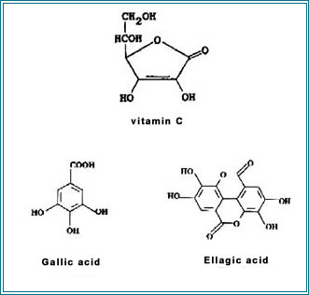

**1.3 Applications of Silver Nanoparticles**

Silver nanoparticles have unique optical, electrical, and thermal properties and are being incorporated into products that range from photovoltaics to biological and chemical sensors. An increasingly common application is the use of silver nanoparticles for antimicrobial coatings, and many textiles, keyboards, wound dressings, and biomedical devices that now contain silver nanoparticles that continuously release a low level of silver ions to provide protection against bacteria.

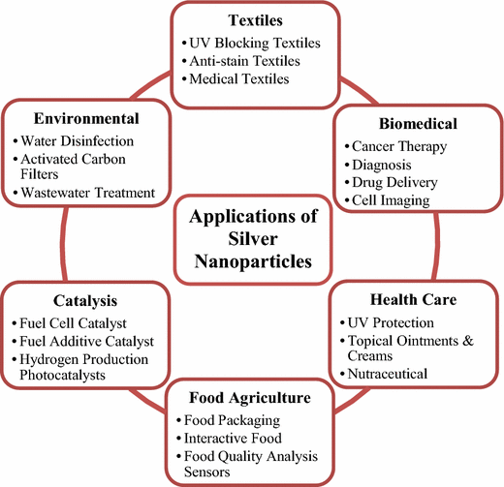

**1.3.1 Applications of Silver Nanoparticles in Wastewater Treatment**

Due to rapid industrialization, dyes have become one of the main sources of severe water pollution as it can be widely used. The release of dyes into our surrounding water bodies has toxic effect on human health and marine life. Conventional biological treatment in removing dyes from wastewaters is generally ineffective as the dyes are resistant to microorganisms. Moreover, the physical and chemical treatment methods are ineffective at higher effluent concentrations.

In recent years, Nanotechnology has been extended to the wastewater treatments. It is a well-known fact that silver nanoparticles and their composites show greater catalytic activity in the area of dye reduction and removal. Due to high surface area they exhibit an enhanced reactivity. Pal et al. studied the reduction of methylene blue by arsine in the presence of silver nano, while Witcomb et al. studied the catalytic activity of AgNPs on the reduction of phenosaffarin dye.

**1.3.2. Methylene Blue**

Methylene blue, also known as methylthioninium chloride, has many uses in biology and chemistry; for example, it can be used as a stain and as a medication. It is a heterocyclic aromatic chemical compound. Methylene blue is a component of a frequently prescribed urinary analgesic/anti-infective/anti-spasmodic known as "Prosed", a combination of drugs which also contains phenyl salicylate , benzoic acid, hyoscyamine sulfate, and methenamine.

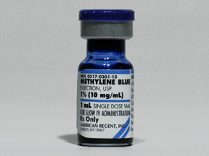

**1.3.2.1. Uses**

Methylene blue injection is used to treat a condition called methemoglobinemia. This condition occurs when the blood cannot deliver oxygen where it is needed in the body. Methylene blue injection is also used as a dye to stain certain parts of the body before or during surgery

∙

**1.3.2.2. Toxicity**

The therapeutic index of very toxic, oxidative drugs could be improved by concurrent treatment with other agents, such as methylene blue, which affect the concn of intracellular reducing agents. In support of this hypothesis, methylene blue was found to protect mice against the toxic effects of doxorubicin without reducing doxorubicin’s antineoplastic activity.

**1.4 Challenges**

The unique physical and chemical properties of silver nanoparticles make them excellent candidates for a number of day-to-day activities, and also the antimicrobial and anti-inflammatory properties make them excellent candidates for many purposes in the medical field. However, there are studies and reports that suggest that nanosilver can allegedly cause adverse effects on humans as well as the environment. It is suggested that at higher concentrations, silver nanoparticles are toxic and can cause various health problems. There are also studies that prove that nanoparticles of silver can induce various ecological problems and disturb the ecosystem if released into the environment.

Though these studies tend to suggest that nanosilver can induce toxicity to living beings, it has to be understood that the studies on nanosilver toxicity were done in in-vitro conditions which are drastically different from in vivo conditions and at quite high concentrations of nanosilver particles. Hence, it is imperative that more studies be carried out to assess the toxicity effect nanosilver has in vivo before a conclusion on its toxicity is reached.

Furthermore, care has to be taken to utilize this marvel well and in a good, effective, and efficient way, understanding its limitations and taking extreme care that it does not cause any harm to an individual or the environment. It can be believed that if utilized properly, silver nanoparticles can be a good friend, but if used haphazardly, they can become a mighty foe.

**CHAPTER 2**

**LITERATURE SURVEY**

1. **T. Jebakumar Immanuel Edison and M.G. Sethuraman (2012)** investigated on a novel green approach for the synthesis and stabilization of silver nanoparticles (AgNPs) using water extract of Terminaliachebula (T. chebula) fruit under ambient conditions. The instant formation of AgNPs was analyzed by visual observation and UV–visible spectrophotometer. Further the effect of pH on the formation of AgNPs was also studied. The synthesized AgNPs were characterized by FT-IR, XRD, HR-TEM with EDS and DLS with zeta potential. Appearance of brownish yellow color confirmed the formation of AgNPs. In the neutral pH, the stability of AgNPs was found to be high. The stability of AgNPs is due to the high negative values of zeta potential and capping of phytoconstituents present in the T. chebula fruit extract which is evident from zeta potential and FT-IR studies. The XRD and EDS pattern of synthesized AgNPs showed their crystalline structure, with face centered cubic geometry oriented in (1 1 1)plane. HR-TEM and DLS studies revealed that the diameter of stable AgNPs was approximately 25 nm. Moreover the catalytic activity of synthesized AgNPs in the reduction of methylene blue was studied by UV–visible spectrophotometer. The synthesized AgNPs were observed to have a good catalytic activity on the reduction of methylene blue by T. chebula which is confirmed by the decrease in absorbance maximum values of methylene blue with respect to time using UV–visible spectrophotometer and is attributed to the electron relay effect.
2. **Khushboo Singh, ManjuPanghal, SangeetaKadyan and Jaya ParkashYadav** (2014) investigated on the comparison of antimicrobial efficacy of silver nanoparticles synthesized from aqueous plant extracts of Phyllanthusamarus and Tinosporacordifolia. The synthesized silver nanoparticles were characterized by UV-VIS spectroscopy, FTIR, TEM, DLS and zeta potential. The antimicrobial activity of synthesized silver nanoparticles was compared with their respective plant extracts by agar well diffusion method and minimum inhibitory concentration was also calculated. The zone of inhibition varied in range of 12 ± 1 to17 ± 0.58 mm with 100 µg/ml silver nanoparticles concentration, while acetonic, methanolic and aqueous extracts of respective plants did not show any activity even at 1 mg/ml i.e. 10 times more than that of silver nanoparticles. MIC of silver nanoparticles was found to be in a range of 6.25-25 µg/ml against all tested microbes. The antimicrobial activity of synthesized silver nanoparticles was higher than that of the standard drug i.e. streptomycin (for bacteria) and ketoconazole (for fungus). The synthesized nanoparticles of P.amarus and T. cordifolia have shown good antimicrobial efficacy as compared to plant extracts and may prove to be better antimicrobial agent against wide range of microbes.
3. **E. M. Evangelin femila, R. Srimathi and D. Charumathi (2014)** optimized the parameters for the AgNPs syntheses using aqueous leaf extract of Aeglemarmelos, evaluated the performance of AgNPs as nanosorbents of synthetic dye Methylene blue and also investigated the performance of AgNPs as nanocatalysts in the reduction of Methylene blue. The effects of parameters such as leaf extract concentration and pH were studied by varying the leaf extract concentration from 5% to 20 % and reaction pH from 3 to 8 respectively. Under optimized leaf extract concentration and pH, AgNPs were synthesized and subjected to biosorption of Methylene blue from aqueous environment. Influence of pH, sorbent dosage and contact time on sorption of dye was investigated. In addition, the Catalytic activity of AgNPs in reduction of the synthetic dye using aqueous leaf extracts of Aeglemarmelos was also investigated. The UV -visible absorption spectra of theAgNPs exhibited distinct band around 400- 460 nm. 20% leaf extract concentration and pH 7 were found to be the optimum conditions for synthesis of AgNPs. Sorption studies on influence of pH, sorbent dosage and contact time showed maximum adsorption at pH 5, 0.3 g and 4 h respectively. The UV visible spectra of the reaction mixture containing aqueous leaf extract of Aeglemarmelos, Malachite Green and AgNPs confirmed the catalytic degradation of Malachite Green. Their study revealed that AgNPs synthesized using aqueous leaf extract of Aeglemarmelos can be used as nanosorbents and nanocatalysts in treatment of dye containing wastewater.
4. **Lunhong Ai and Jing Jiang (2013)** presented that the macroscopic biopolymer alginate hydrogels (AHs) could be used directly as a green and effective carrier to stabilize silver nanoparticles (AgNPs). The AgAHs was characterized by UV–vis absorption spectroscopy, FTIR, SEM and X-ray energy dispersive spectroscopy (EDS). The AgAHs showed excellent catalytic performance for the reduction of 4- nitrophenol by NaBH4 in aqueous solution, which can be easily separated after catalytic reaction and readily reused for three successive reaction cycles, attributing to the high stability of the AgNPs supported by AHs. Their findings shed a light on the design and fabrication of new heterogeneous catalyst with high performance based on the environmentally benign biopolymer hydrogel.
5. **J. Kasthuri, K. Kathiravan and N. Rajendiran (2009)** investigated on the synthesis of the anisotropic gold and spherical–quasi-spherical silver nanoparticles (NPs) by reducing aqueous chloroauric acid (HAuCl4) and silver nitrate (AgNO3) solution with the extract of phyllanthin at room temperature. The rate of reduction of HAuCl4 is greater than the AgNO3at constant amount of phyllanthin extract. The size and shape of the NPs can be controlled by varying the concentration of phyllanthin extract and thereby to tune their optical properties in the near-infrared region of the electromagnetic spectrum. The case of low concentration of extract with HAuCl4 offers slow reduction rate along with the aid of electron-donating group containing extract leading to formation of hexagonal-or triangular-shaped gold NPs. TEM analysis revealed that the shape changes on the gold NPs from hexagonal to spherical particles with increasing initial concentration of phyllanthin extract. The FTIR and thermogravimetric analyses reveal the interaction between NPs and phyllanthin extract. The cyclic voltammograms of silver and gold NPs confirms the conversion of higher oxidation state to zero oxidation state.
6. **R.Subbaiya1, R.S.Lavanya1, K.Selvapriya and M.MasilamaniSelvam (2014)** investigated on an environmental friendly approach employed to synthesize silver nanoparticles. The biomolecules found in plants induce the reduction of Ag+ ions from silver nitrate to silver nanoparticles (AgNPs). UV-visible spectrum of the aqueous medium containing silver ions demonstrated a peak at 404nm corresponding to the plasmon absorbance of silver nanoparticles. FTIR spectroscopy was done to find the functional groups present. Antioxidant activities were done using DPPH antioxidant assay and Hydrogen Peroxide assay. Plants during glycolysis produce a large amount of H+ ions along with NAD which acts as a strong redoxing agent; this seems to be responsible for the formation of AgNPs. AgNPs produced show good antimicrobial activity against common pathogens.
7. **TamasaPanigrahi (2013)** investigated on the biological approach of preparation of silver nanoparticles, because, this method is easier than the other methods, eco- friendly and less time consuming. The Green synthesis was done by using the aqueous solution of Azadirachtaindica leaf extract and AgNO3. Silver was of a particular interest for this process due to its evocative physical and chemical properties. A fixed ratio of plant extract to metal ion was prepared and the color change was observed which proved the formation of nanoparticles. The nanoparticles were characterized by UV-vis Spectrophotometer, FTIR, DLS, Zeta Analysis, XRD, and SEM. The nanoparticles were found have the size ranges from 160-180 nm.
8. **SukumaranPrabhu and Eldho K Poulose (2012)** provided with a comprehensive view on the mechanism of action, production, applications in the medical field, and the health and environmental concerns that are allegedly caused due to the silver nanoparticles. The focus was on the effective and efficient synthesis of silver nanoparticles while exploring their various prospective applications besides trying to understand the current scenario in the debates on the toxicity concerns these nanoparticles pose.
9. **N. Vigneshwaran, N.M. Ashtaputre, P.V.Varadarajan, R.P. Nachane, K.M.Paralikar and R.H. Balasubramanya (2006)** investigated on the biological synthesis of silver nanoparticles using the fungus Aspergillusflavus which when challenged with silver nitrate solution accumulated silver nanoparticles on the surface of its cell wall in 72 h. These nanoparticles dislodged by ultra-sonication showed an absorption peak at 420 nm in UV–visible spectrum corresponding to the plasmon resonance of silver nanoparticles. The TEM analysis showed the production of reasonably monodispersed silver nanoparticles (average particle size: 8.92±1.61 nm) by the fungus. X-ray diffraction spectrum of the nanoparticles confirmed the formation of metallic silver. The FTIR spectroscopy confirmed the presence of protein as the stabilizing agent surrounding the silver nanoparticles. These protein-stabilized silver nanoparticles produced a characteristic emission peak at 553 nm when excited at 420 nm in photoluminescence spectrum. The use of fungus for silver nanoparticles synthesis offers the benefits of Eco friendliness and amenability for large-scale production.
10. **Mohanan V. Sujitha and SoundarapandianKannan (2012)** reported the biological synthesis of gold nanoparticles by the reduction of HAuCl4 by using citrus fruits (Citrus limon, Citrus reticulata and Citrus sinensis) juice extract as the reducing and stabilizing agent. A various shape and size of gold nanoparticles were formed when the ratio of the reactants were altered with respect to 1.0 Mm chloroauric acid solution. The gold nanoparticles obtained were characterized by UV–visible spectra, TEM and XRD. TEM studies showed the particles to be of various shapes and sizes and particle size ranges from 15 to 80 nm. Selected-area electron diffraction (SAED) pattern confirmed fcc phase and crystallinity of the particles. The X-ray diffraction analysis revealed the distinctive facets (111, 200, 220 and 222 planes) of gold nanoparticles. Dynamic light scattering (DLS) studies revealed that the average size for colloid gp3 of C. limon, C. reticulata and C. sinensis are 32.2 nm, 43.4 nm and 56.7 nm respectively.
11. **Anish Stephen and SankarSeethalakshmi (2013)** developed a rapid and ecofriendly method for synthesis of silver nanoparticles from aqueous solution of silver nitrate using the flavonoid “hesperidin” and optimization of the methodology. There is formation of stable spherical silver nanoparticles in the size range of 20–40nm. Optimization of methodology in terms of concentration of reactants and pH of the reaction mixture reduced the reaction time for silver nanoparticle formation to 2mins. Silver nanoparticles (AgNPs) were characterized by UV-Vis spectroscopy and TEM. UV-vis spectroscopy derived spectrum demonstrated a peak of 430nm which corresponds to the Plasmon absorbance of silver nanoparticles. Transmission electron microscopy revealed spherical shaped silver nanoparticles in the size range of 20–40nm.
12. **Nithya.R and Ragunathan.R (2011)** reported the decolorization of the dye congo red by silver nanoparticle synthesized by using Pleurotussajorcaju a white rot fungi and its comparison with its plain culture (Pleurotussajorcaju).The characterization of silver nanoparticle was done by using UV-visible spectroscopy, FTIR and scanning electron microscopy. The nanoparticles were synthesized in the size range of 40nm. These particles were then checked for their efficiency to decolorize the dye congo red. The Pleurotussajorcaju silver nanoparticle effectively decolorized the dye within 24hours of incubation when compared with its plain culture (Pleurotussajorcaju) which takes more than 48 hours for the same process. This is for the first time reporting that Pleurotussajorcaju silver nanoparticle was used for the decolorization of the dye Congo red.
13. **So Hyun Lee, Bipinchandra K. Salunke, and BeomSoo Kim (2014)** demonstrated that the Magnolia kobus plant extract produces a diverse mixture of extracellular gold and silver nanocrystals with a majority of polydispersed spheres; however, there are a significant number of homogeneously sized triangles, pentagons, and hexagons. The gold and silver nanoparticles synthesized using the M. kobusplantextract can be separated using density gradient centrifugation in the size range of 52 ~ 117 nm and 38 ~ 61 nm, respectively. The average particle sizes increase with increases in the sucrose concentration of each layer. Relatively larger but long, thin plates of gold nanoparticles appear in the higher density sediments, whereas a larger proportion of smaller spheres featured in the lower density gradients.Similarly, silver nanospheres of different sizes are separated at different density gradients with smaller proportions of plates.
14. **Vikassarsar, Manjit k. selwal and Krishankumarselwal(2013)** focused on the optimization of the synthesis conditions of silver nanoparticles using Psidiumguajava leaf extract as reducing agent. The synthesis of silver nanoparticles was carried out taking into account the optimization of the conditions for the synthesis of silver nanoparticles. For this reason, the variation of parameters like the concentration of the silver precursors, reducing agent, pH, temperature and time of synthesis were realized. The silver nanoparticles were characterized by UV-Visible spectroscopy, X-ray diffraction (XRD), Fourier transform infra-red spectroscopy (FTIR) and transmission electron microscopy (TEM) techniques. The synthesized silver nanoparticles showed antimicrobial activity against bacterial strains.
15. **Bashir Ahmad, Javid Ali and Shumaila Bashir (2013)** investigated the findings of optimization of different experimental variables conditions like reaction pH, silvernitrate concentrations, time, temperature and mixing ratio of the reactants on silver nanoparticles synthesized using aqueous extract of Hippophaerhamnoides L. (Seabuckthorn) leaves. The formation of yellowish brown color was confirmed the synthesis of silver nanoparticles. The optimized condition for the bio inspired synthesis of silver nanoparticles revealed that silver nitrate concentration was 1mM, temperature was 75°C, pH was 7, incubation time was 1 h and aqueous extract and silver nitrate ratio was 5:95. It can be observed from the finding that good modification of the bioprocess parameters will improve potential of desired nano-product for particular applications.

**CHAPTER-3**

**EXPERIMENTAL WORK**

**3.1. MATERIALS REQUIRED**

∙ Silver Nitrate

∙ Methylene blue

**3.1.1. SILVER NITRATE**

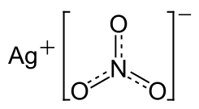

**Fig. 3.1.1.1 Structure of Silver Nitrate**

Silver nitrate is an inorganic compound with chemical formula AgNO3. This compound is a versatile precursor to many other silver compounds, such as those used in photography.

**PROPERTIES OF SILVER NITRATE**

Molar mass: 169.87 g/mol

Formula: AgNO3

Density: 4.35 g/cm³

Melting point: 212 °C

Boiling Point: 444°C

Soluble in: Water

**3.1.2. METHYLENE BLUE**

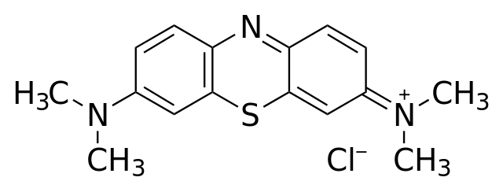

**Fig.3.1.2.1 Structure of methylene blue**

Molar mass: 319.85 g/mol

Molecular formula: C16H18N3SCl

**3.2. METHODOLOGY**

**3.2.1 PREPARATION OF EXTRACT**

Fresh fruits of ***Phyllanthus*** ***emblica*** were bought farm fresh from Chennai and washed with distilled water. A known quantity (5g) of fruit were ground with the help of mortar and pestle and boiled with 100 mL of distilled water at 65ºC for forty five minutes. The mixture was then filtered using Whatman 40 filter paper. The extract was immediately used for the study.

**3.2.2. SYNTHESIS OF SILVER NANOPARTICLES**

The aqueous solution of 1 mM silver nitrate (AgNO3) was prepared and used for the synthesis of silver nanoparticles. 10 ml of aqueous fruit extract was added to 90 ml of freshly prepared aqueous solution of 1 mM silver nitrate. The solution was boiled for 15-20 minutes at 60-70ºC. The synthesis of AgNPs was monitored by visual observation and UV-visible spectral analysis. The solution was centrifuged for 25 min at 3500 rpm. The AgNPs pellet was collected, washed and dried at room temperature.

**3.4. ANALYSIS**

**3.4.1. UV–visible spectroscopic characterization of AgNPs**

The AgNPs were characterized in a Shimadzu UV-VIS Spectrophotometer. The scanning range for the samples was 300-600 nm. The double distilled water used as a blank reference.

**3.4.2. Scanning Electron Microscopy (SEM)**

The shape and size of the synthesized AgNPs was determined by transmission electron microscopy. A drop (2 µl) of water that dissolved synthesized nanoparticles was placed on a copper grid. The images were obtained with a TECNAI10-Philips, Twin 200 KV (FEI, Netherlands) at a bias voltage of 200 kV used to analyze samples.

**3.4.3 Fourier Transform Infrared Spectroscopy (FTIR)**

The functional groups present in the synthesised solution is determined using fourier transform infrared spectroscopy, where an infrared spectrum of absorption is obtained.The surface of the ftir is first cleansed using ethanol and the sample is placed on the surface using syringe. 2 ml of the solution is taken and the probe is immersed and the analysis to carried out to obtain a infrared spectrum with different peaks ,varying with functional groups.

**3.4.4 Gas Chromotography-Mass Spectroscopy(GCMS)**

Gas Chromatography Mass Spectrometry (**GC-MS**) is a technique for the analysis and quantitation of organic volatile and semi-volatile compounds. Gas chromatography (GC) is used to separates mixtures into individual components using a temperature-controlled capillary column.

**3.4.4 Evaluation of effect of synthesized AgNPs on the reduction of Methylene blue by Phyllanthus emblica leaf extract**

In order to assess the catalytic activity of synthesized AgNPs, two reactions were carried out in a 3.5 ml capacity quartz cuvette and absorbance values were monitored using UV–visible spectrophotometer. In the first reaction, 1 ml of Methylene Blue (20ppm) was mixed with 1mg of the produced silver nanoparticles with phyllanthus emblica and 1. 8 ml of water and the reaction was monitored after 2 min. In second reaction, 1 ml of Methylene Blue (20ppm) was mixed with 1mg of the produced silver nanoparticles with phyllanthus emblica and 1. 8 ml of water and the reaction was monitored after 4 min. In all the reactions total volume of the mixture was made up to 3 ml. The values of absorption maxima of the reaction mixtures were compared with that of Methylene Blue.

**CHAPTER-4**

**RESULTS AND DISCUSSIONS**

**4.1. Results**

In present work, we have synthesized the silver nanoparticles from aqueous extract of Phyllanthus emblica. Further we have evaluated the catalytic activity of the synthesized AgNPs on reduction of Methylene Blue dye.

**4.2. Synthesis of AgNPs by green synthesis process**

The green synthesis of silver nanoparticles through plant extracts were carried out. On mixing the aqueous plant extract of Phyllanthus emblica with silver nitrate solution (1 mM), a change in the color from pale yellow to dark brown was observed.

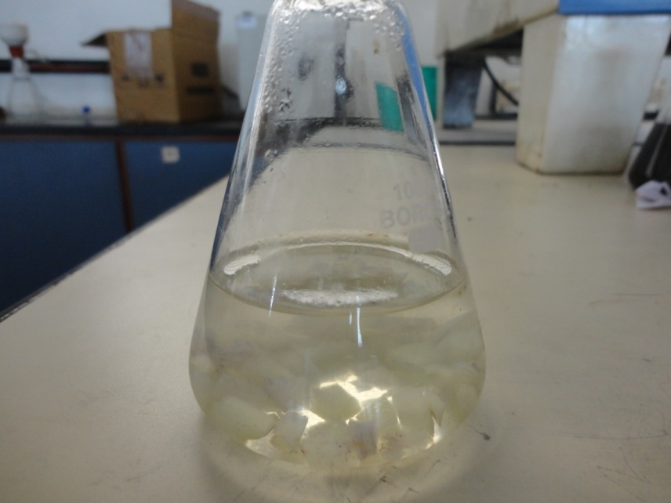

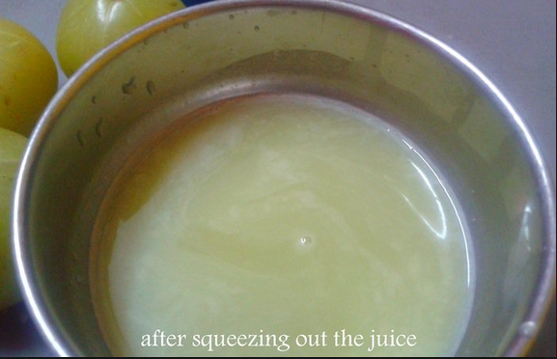

**Fig.4.2.1. Plant extract**

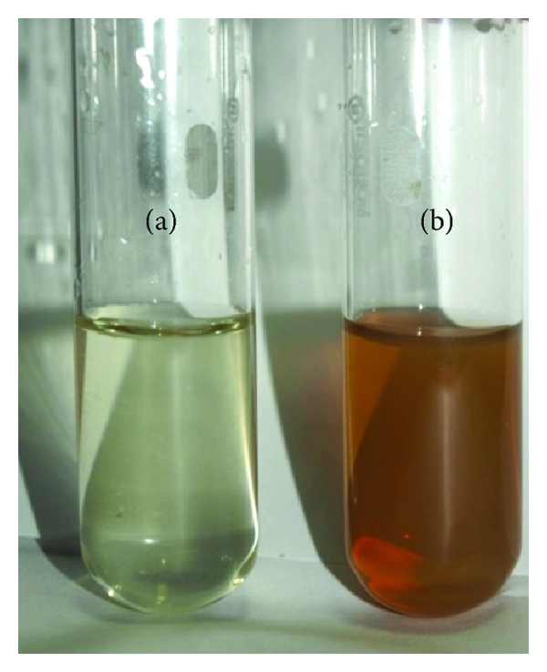

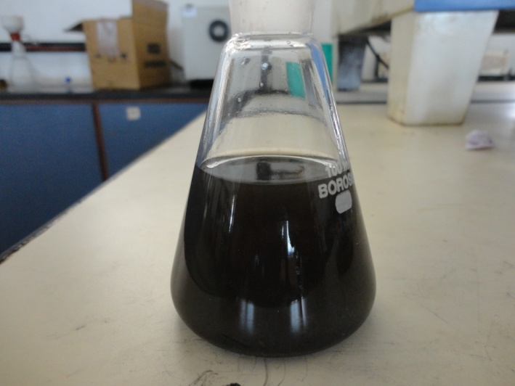

**Fig.4.2.1. Extract after the addition of AgNO3**

The extract obtained from fruit pulp turned dark brown in color, after the addition of AgNO3 solution. The solution was centrifuged and the particles were separated and allowed to be dried on watch glass to be scraped up as Silver nanoparticles

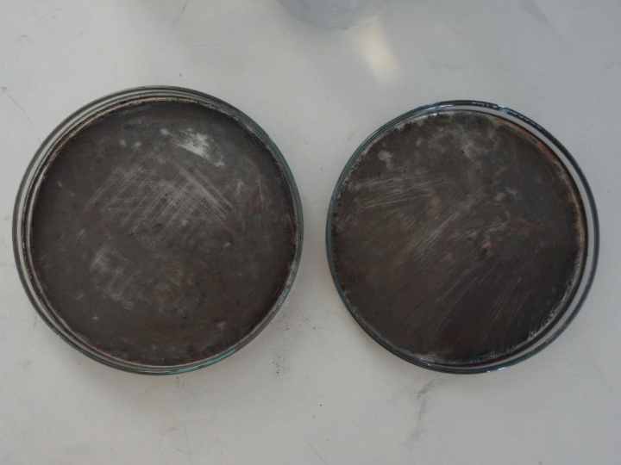

**Fig.4.2.2. After centrifuge and drying.**

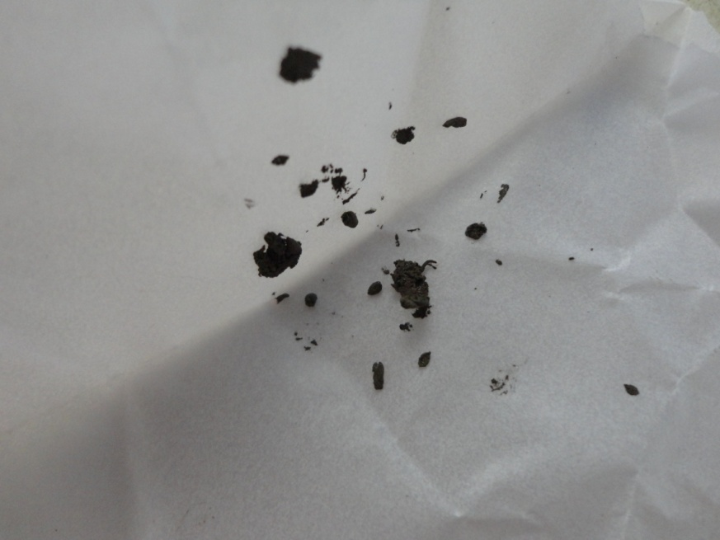

**Fig.4.2.3 Silver Nanoparticles**

**4.3. UV Visible Spectroscopy**

The formation of nanoparticles was easily detected and characterized by UV– visible spectroscopy owing to the surface Plasmon resonance (SPR), i.e., the interaction of electromagnetic radiation and the electrons in the conduction band around the nanoparticles. The localized SPRs are collective oscillations of the conduction electrons confined to metallic nanoparticles. Excitation of the localized surface plasmons causes strong light scattering by an electric field at a wavelength where resonance occurs; this phenomenon results in the appearance of strong SPR bands. The optical absorption spectrum of metal nanoparticles is dominated by the SPR, which exhibits a shift towards the red end or blue end

depending upon the particle size, shape, state of aggregation and the surrounding dielectric medium. AgNPs were observed strongly in the range of 400–450 nm in visible region.

In the present work, the AgNPs are rapidly formed after the addition of phyllanthus amarus extract, evident from the appearance of brownish yellow color and the peak appearing at 430nm.

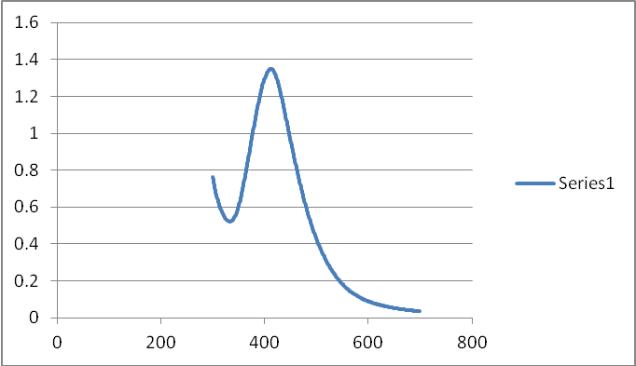

**Fig 4.3.1. Figure showing Absorption spectra of AgNPs obtained from pulp with peak at 430nm**

**4.4. Total phenolic content determination (TPC)**

The TPC assay is a common assay widely used to estimate relative amounts of phenolic compounds present in an extract. The TPC results were expressed as mg gallic acid equivalent as this compound represents the most simple form of a phenolic compound. Phenolic compounds present in the extract undergo a complex redox reaction with phosphotungstic and phosphomolybdic acids present in the TPC reagent. Depending on the number of phenolic groups present, different response can be observed in terms of the color change due to oxidation of the TPC reagent. This color change is detected by a spectrophotometer and quantified in term of mg gallic acid equivalent per dry weight of the plant. The results for the TPC analysis indicate that aqueous extract of Phyllanthus amarus contain significant amounts of phenolic compounds 64.771 mg GAE / g dry weight of the plant.

**4.5. Mechanism of reduction of AgNO3 to AgNPs by the phytoconstituents of P. emblica**

The main mechanism considered for the process is plant-assisted reduction due to phytochemicals. The main phytochemicals involved are terpenoids, flavones, ketones, aldehydes, amides, and carboxylic acids. Flavones, organic acids, and quinones are water soluble phytochemicals that are responsible for the immediate reduction of the ions. Studies have revealed that P. amarus contain mainly phyllanthin, hypophyllanthin, phyltertralin and many more other phytochemicals. It was also suggested that the phytochemicals are involved directly in the reduction of the ions and formation of silver nanoparticles. Though the exact mechanism involved in each plant varies as due to the presence of different phytochemicals are involved in the production of AgNPs.

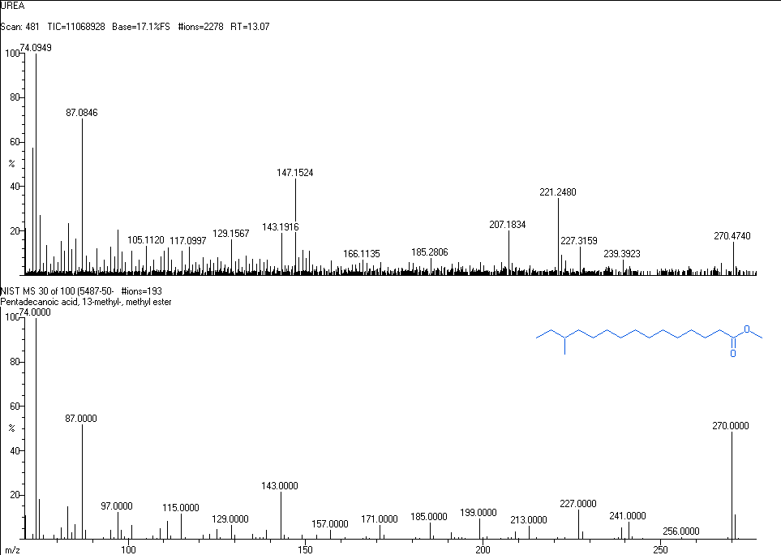

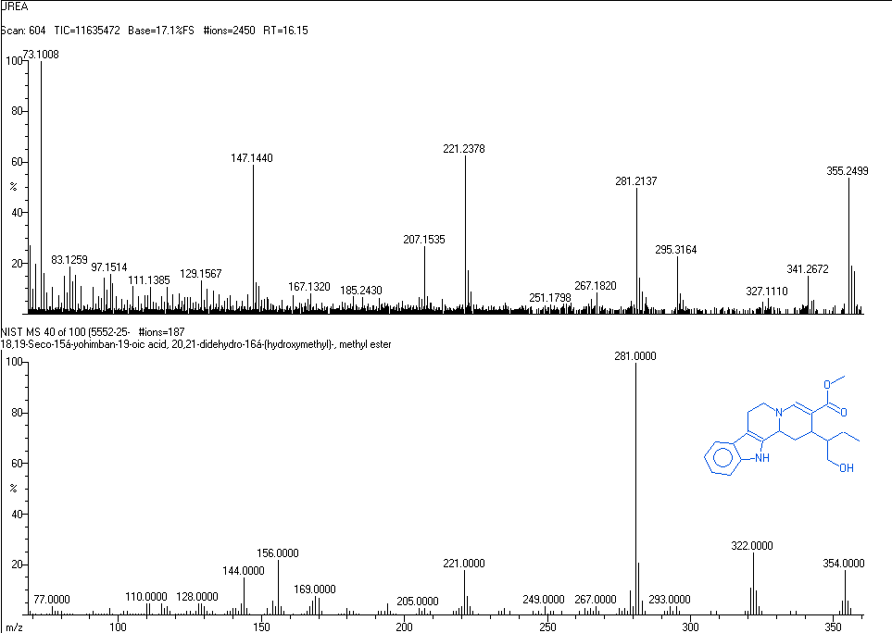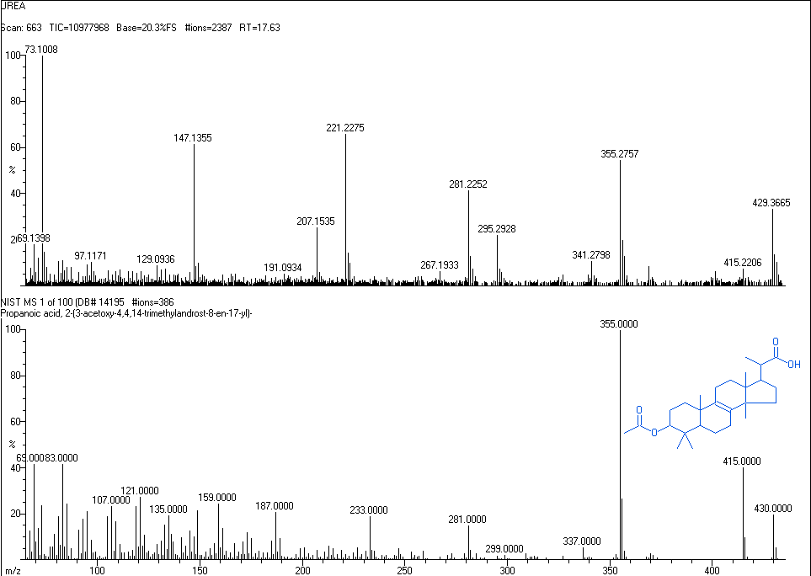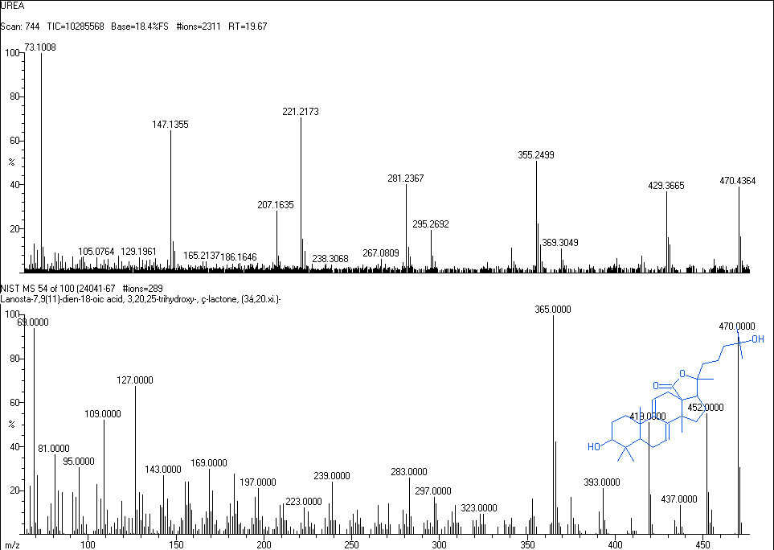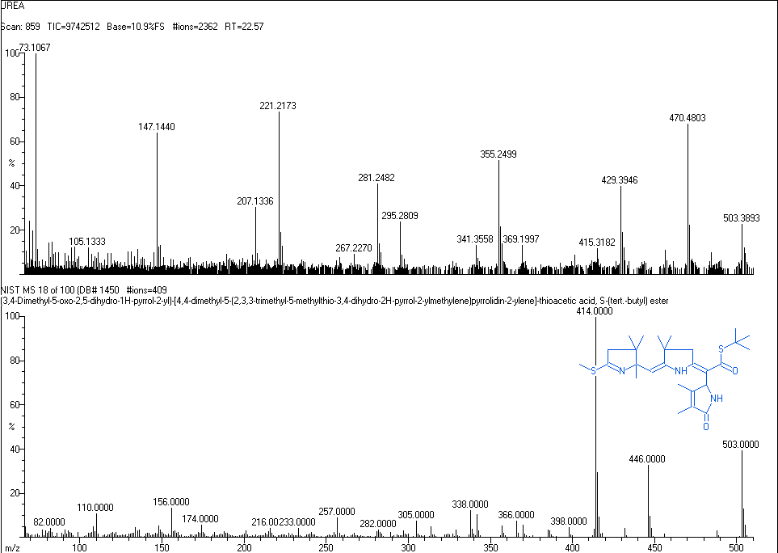

**4.6. Optimization of the silver nitrate concentration in the synthesis of silver nanoparticles**

Effect of AgNO3 concentration on the synthesis of silver nanoparticles was studied by varying the concentration of AgNO3. The study of Amit, Abhishek and Uttam found that the increase in yield of AgNPs was observed when the metal salt concentration was increased from 0.2-1 mM. Beyond this there was a fall in absorbance. In our present study, 0.1mM concentration of silver nitrate solution was not able to produce AgNPs and thus there was no peak obtained in the UV-Vis analysis (Fig.4.6.1).Increase in absorbance was observed when the concentration of AgNO3 was increased from 0.2 to 1 mM. Beyond this there was a fall in absorbance. Therefore we conclude that 1 mM AgNO3 concentration is the optimized value.

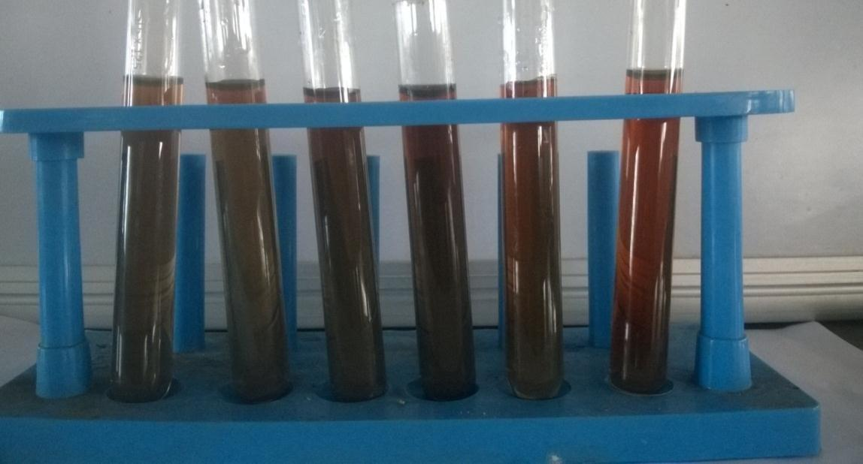

**Fig.4.6.1. Effect of varying AgNO3 concentration on synthesis of AgNPs**

**Table 4.6.1. Variation of absorbance with AgNO3 concentration**

|  |  |
| --- | --- |
| **CONCENTRATION**  **(mM)** | **ABSORBANCE** |
| 0.2 | 0.4605 |
| 0.4 | 0.61 |
| 0.6 | 1.541083333 |
| 0.8 | 2.0621 |
| 1.0 | 2.672762646 |

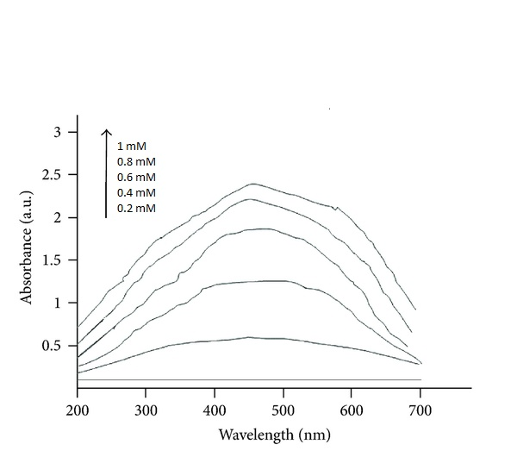

**4.7. Fourier Transform Infrared spectroscopy**

An infrared spectrum represents a fingerprint of a sample with absorption peaks which correspond to the frequencies of vibrations between the bonds of the atoms making up the material. Because each different material is a unique combination of atoms, no two compounds produce the exact same infrared spectrum. Therefore, infrared spectroscopy can result in a positive identification (qualitative analysis) of every different kind of material. In addition, the size of the peaks in the spectrum is a direct indication of the amount of material present. With modern software algorithms, infrared is an excellent tool for quantitative analysis.

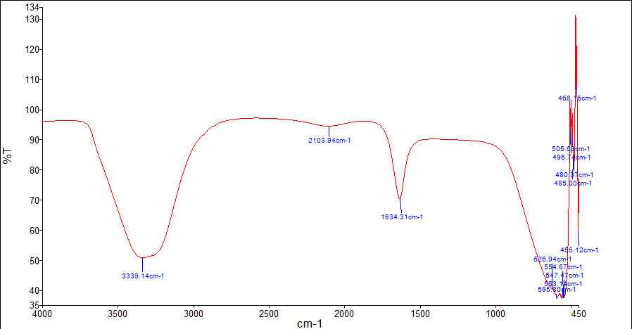

**4.8. Catalytic activity of synthesized AgNPs on the reduction of methylene blue by Phyllanthus emblica pulp extract**

It is a well-known fact that AgNPs and their composites show great catalytic activity in the area of dye reduction and removal. Pal et al. studied the reduction of Methylene Blue by arsine in the presence of Silver Nanoparticles. Mallick et al. studied the catalytic activity of AgNPs on the reaction of phenosaffranin dye. The present study aims at the reduction of Methylene blue by the natural green aqueous leaf extract of Phyllanthus emblica containing AgNPs. Pure Methylene blue was observed to have a λmax of 616 nm. Sixty minutes after the addition of the extract to the dye, the absorbance is gradually decreased in the first reaction. The decrease of absorbance is indicative of the ability of phytoextract to degrade Methylene Blue. In the second reaction system containing the dye, AgNPs and the extract, at the end of 60 min showed a marked decrease in the absorbance of Methylene Blue and increase of SPR peak of AgNPs (Fig. 4.6.1). This reveals AgNPs act as an electron transfer mediator between the extract and Methylene blue by acting as a redox catalyst, which is often termed as electron relay effect.

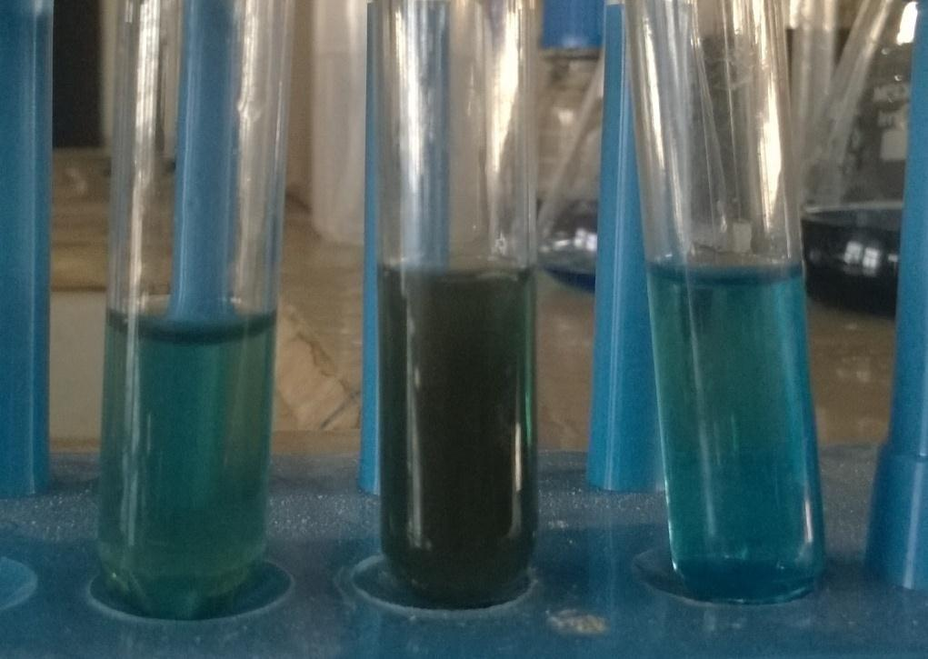

**Fig.4.7.1. Reduction of Methylene Blue dye**

**Table 4.7.1 Change in absorbance of Methylene blue dye**

|  |  |  |
| --- | --- | --- |
| **CONSTITUENTS** | **ABSORBANCE** | **PERCENTAGE**  **REDUCTION (%)** |
| Methylene blue dye | 3.12 | - |
| Methylene blue dye +  AgNPs (2min) | 1.32 | 42.30 |
| Methylene blue dye +  AgNPs (4min) | 1.14 | 86.36 |

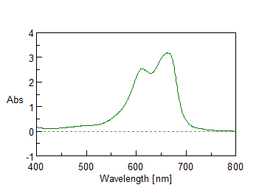

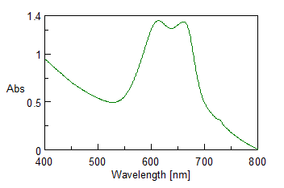

**Fig 4.7.1 UV-Visible Spectra of reaction mixtures containing Methylene blue alone; Methylene blue, and biosynthesized AgNPs.**

**4.8. Scanning Electron Microscope (SEM) analysis.**

The shape and size of the synthesized AgNPs was determined by transmission electron microscopy. A drop (2 µl) of water that dissolved synthesized nanoparticles was placed on a copper grid. The images were obtained with a TECNAI10-Philips, Twin 200 KV (FEI, Netherlands) at a bias voltage of 200 kV used to analyze samples.

**The particles produced were in Nanometer range.**

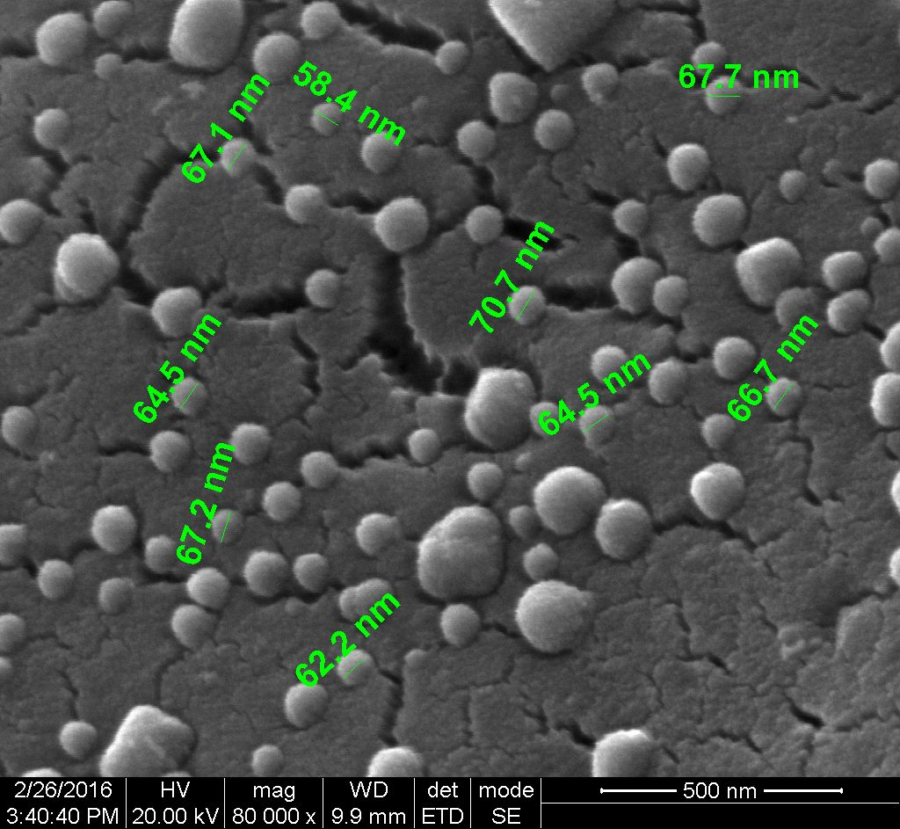

**CHAPTER-5**

**DESIGNING OF APPARATUS**

1. Design a continuous distillation column (plate) to recover acetone from a 50-50 mole % acetone-water mixture available at 30°C. The feed stream flow rate is 25,000 kg/h. The top product should contain at least 95 mole% acetone and the bottom product should contain <1 % acetone by mole. Consider reboiler as equivalent to one stage. This column is operated at atmospheric pressure (top tray). Column efficiency of 60% and pressure drop per plate of 1.25 kPa may be assumed. You can take the minimum liquid flow as 70% of the maximum rate both above and below the feed plate. The vapor liquid equilibrium (VLE) data for the acetone-water system at atmospheric pressure is provided in the table.

Data given: Latent heat of water= 41,360 J/mol; latent heat of acetone= 28,410 J/mol Specific heat of water=75.3 J/mol°C (mean); Specific heat of acetone 128 J/mol°C (mean); Density of acetone= 791 Kg/m3

**VLE data for the acetone-water system at 1 atm.**

|  |  |  |  |  |  |  |  |  |  |  |  |  |  |  |  |  |  |  |  |  |
| --- | --- | --- | --- | --- | --- | --- | --- | --- | --- | --- | --- | --- | --- | --- | --- | --- | --- | --- | --- | --- |
| X | 0.0 | 0.05 | 0.1 | 0.15 | 0.2 | 0.25 | 0.3 | 0.35 | 0.4 | 0.45 | 0.5 | 0.55 | 0.6 | 0.65 | 0.7 | 0.75 | 0.8 | 0.85 | 0.9 | 0.95 |
| Y | 0.0 | 0.6381 | 0.7301 | 0.7716 | 0.7916 | 0.8034 | 0.8124 | 0.8201 | 0.8269 | 0.8376 | 0.8387 | 0.8455 | 0.8532 | 0.8615 | 0.8712 | 0.8817 | 0.895 | 0.9118 | 0.9335 | 0.9627 |
| BP(OC) | 100 | 74.8 | 68.53 | 65.26 | 63.59 | 62.6 | 61.87 | 61.26 | 60.75 | 60.35 | 59.95 | 59.54 | 59.12 | 58.71 | 58.29 | 57.9 | 57.49 | 57.08 | 56.68 | 56.3 |

𝑥= Mole fraction of acetone in liquid; 𝑦= Mole fraction of acetone in vapor; BP: Bubble point

Step #1: Mass balance and determination of number of theoretical stage Feed and products compositions:

|  |  |  |  |
| --- | --- | --- | --- |
| Component | Feed mole fraction | Top product mole  fraction | Bottom product mole Fraction |
| Acetone | 0.50 | 0.95 | 0.01 |
| Water | 0.50 | 0.05 | 0.99 |

Bubble point of feed (from the data shown in table) = 59.95°C

Latent heat of the feed = 28,410×0.5 + 41,360×(1 - 0.5) = 34,885 J/mol

Specific heat of the feed = (128×0.5) + 75.3× (1 - 0.5)= 101.75 J/mol °C

Heat required to vaporize 1 mole of the given feed = (59.95 - 30) ×101.75 + 34,885=37933 J

𝑞 =Heat required to vaporize 1 mole of the given feed / Latent heat of the feed

=37933/ 34885 = 1.09

Slope of the q-line= 𝑞/ 𝑞−1 = 1.09/ 1.09−1 = 12.44

Here, the top operating line just touches the equilibrium curve at the point of tangency of the rectifying section operating line at which the minimum reflux takes place.

XD/(Rmin +1) = 0.57,

Rmin = 0.67 for xD = 0.95

Here, reflux ratio, R=2.5×Rmin =2.5×0.67= 1.675 is taken for this design.

Average molecular wt. of feed= 0.5×58 + 0.5×18=38

Molar feed flow (𝐹) rate=25,000/38=657.9 kmol/h

Acetone balance: 𝐷 ×0.95 = 657.9×0.5⇒𝐷 = 346.2 kmol/h

Vapor flow (𝑉) rate above feed plate, 𝑉 = 𝐷 1+𝑅 = 346.2 1+1.675 = 926.2 kmol/h (Assuming constant molar overflow)

Top section liquid flow rate, 𝐿 = 𝑉 − 𝐷 = 580 kmol/h

Bottom product: 𝐵 = 𝐹 −𝐷 = 657.9−346.2 = 311.7 kmol/h

Mass balance below feed plate: 𝐿′ = 𝑉′ +𝐵

Slope of the bottom section operating line (Figure 7.8): 𝐿′ 𝑉′ = 1.32 𝐿′= Liquid flow rate below feed plate = 1285.7 kmol/h

𝑉′= Vapor flow rate below feed plate = 974 kmol/h

Total number of tray= 6 (above feed) +3 (below feed) =9 Total number of real stages= 9−1/ 0.6 ≈ 14

(60% column efficiency; reboiler was considered as equivalent to one theoretical tray)

Height of the tower (H)= 2.3 * Number of trays= 14* 2.3= 32.2 feet

Vapour velocity (V)= 1.2/ SQRT(Density of acetone)= 0.0426 KPa

Diameter of the tower (D)= 0.164 *SQRT(V) *( Molecular weight of the gas/ density of the gas) 0.25 = 1.76m

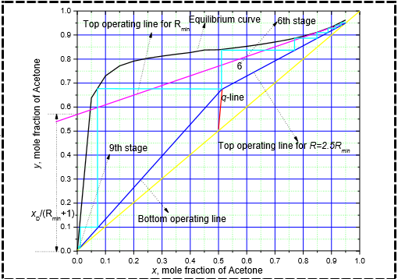

DESIGN SUMMARY:

1. Top section liquid flow rate- 580 kmol/h
2. Bottom product- 311.7 kmol/h
3. Liquid flow rate below feed plate = 1285.7 kmol/h
4. Vapour flow rate below feed plate- 974 kmol/h
5. Total number of tray- 14
6. Height of the tower- 32.2 feet
7. Diameter of the tower- 1.76 m

**2) Design - Batch Reactor**

**Process Flow Sheet:**

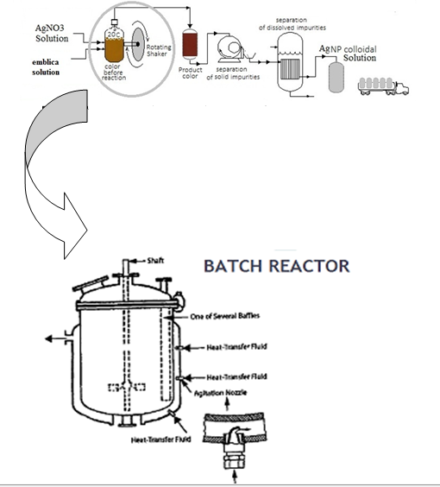

Batch reactor consists of an agitator and a jacket around it for cooling purposes

Jacket consists of agitation nozzles for providing higher turbulence and hence better heat transfer

**Assumptions used** :

The reactor used is a batch reactor with agitator

The conversion is 70 % and for that conversion the reaction time is 48 hrs

**Solution:**

**Step 1 :**

In sizing of a batch reactor, the following rate equation have to be followed to calculate the reaction time;

ri = (1/V)dNi/dt=d(Ni/V)/dt=dCi/dt

A→products

-rA=dCA/dt=kCA

-lnCA/CA0=kt

dXA/dt=k(1-XA)

-ln(1-XA)=kt

**Process design**

As we assumed that, for a conversion of 70%, the time taken for the batch reaction is 48 hrs. The following equation was then used to calculate the entire batch time

      tB’ = tF’+tR’+tC’+tE’

Where;

tF’ = Time needed for filling.

tR’ = Time taken for reaction.

tC’ = Time taken to cool.

tE’ = Time taken for emptying and cleaning.

tB’  = Time taken for the entire batch operation.

Time required for the entire batch operation:

Charging time (tF’ ): 2 hrs.

Cooling time (tC’) : 1.5 hrs.

Reaction time (tR’): 48 hrs.

Emptying and cleaning time (tE’) : 0.5 hrs.

Total time for batch (tB’): 2 + 1.5 + 48 + 0.5 = 52 hrs.

**Volume of Reactor:**

Conversion = 70%.

Reaction Time = 48 hrs.

Batch Time **(tB’)** = 52 hrs.

Working Pressure of Vessel **(P)** = 180 kPa

Temperature of Reaction = 32oC.

pH = 4.8

Mass flow rate in **(ml’)** = 6700 Kg/hr.

Density of Material in reactor  **(ρ’)** = 1200 Kg/m3.

Now;

tB’  = 52 hrs.

Density of Feed (ρ’) = 1200 Kg/m3.

**Vr=m1’tb/ρ**

Now;

ml’ = 6700 Kg/hr

Therefore;

Vr = 6700 x 52

   1200

**VR = 290 m3.**

**VR= 290 m3**

H/D = 1.5

**VR = π x (D2/4) x L**

= **π**  x (D2/4) x 1.5D

= (3/8)**π** x (D3)

VR = 290 m3

Hence, putting in above equation;

D = 6.3 m

H = 10 m

Now  Assume ,

Height of Dished Bottom = 1 m

Therefore;

**Total Height = 10 + 1 = 11 m**

**Mechanical design** :

**WALL THICKNESS**

For the calculation of wall thickness we have to calculate the total pressure which is the sum of static pressure and operating  pressure of the reactor.

Static Pressure (Ps) = *ρ’ x g x H*

= (1200 x 9.81 x 10)/1000

= 117.72 kPa

Total Pressure at base = Ps  + P

= 297.72 kPa

Maximum allowable pressure = 1.33 (297.72)

=  395.96 kPa

Wall thickness =   *P𝒙 ri       + Cc*

*SEj – 0.6P*

Material = Carbon Steel

Working Stress of Carbon Steel,S = 94408 KN/m2

Joint Efficiency, Ej = 0.85

Internal Radius, ri = 3.4 m

Corrosion allowance = 0.002m

Therefore wall thickness = 0.017 + *Cc*

*=* 0.017+ 0.002

= 0.017m = 17mm

**Therefore outside diameter = Di + 2t = 6.3m**

**Reactor Head**

There are three types of heads ,

• Ellipsoidal Head

•Torispherical Head

•Hemispherical Head

Ellipsoidal head is used for pressure greater than 150 psi and for less than that pressure we use Torispherical head. That is why we have selected a Torispherical head

**TORISPHERICAL HEAD :** 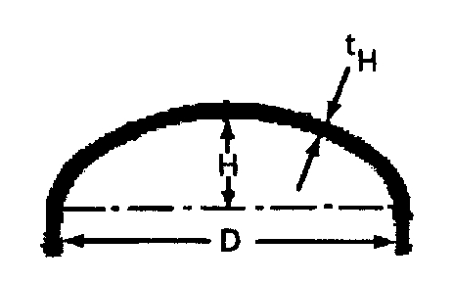

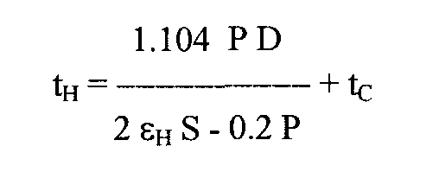

**=**0.0167 + 0.002

= 0.0187m

≃ 19mm

**Agitator Design**:

Agitator Dimensions are:

Impeller Diameter      Da = Dt/3 = 2.1 m

Impeller Height above Vessel floor         E   = Da  = 2.1 m

Length of Impeller Blade                         L   = Da /4

                                                                            = 0.525 m

Width of Impeller Blade                            W  = Da /5

                                                                         = 0.4 m

Width of Baffle                            J   = Dt/10 = 0.63 m

No. of Impellers = 3

No. of Impeller blades = 6

Distance between 2 consecutive impellers = 2.1 m

Assume, that the Tip velocity ranges from,

Tip Velocity = 3 – 6  m/sec

So take a value ,

Tip Velocity = 5 m/sec

But ,

Tip Velocity = π x Da x N

therefore,

Speed of Impeller = N = [5/( π x 2.2)] x 60 = 46 RPM

Power no (Np )= 6.

Shaft RPM (N)= 46 RPM = 0.76rev/sec

Power = (Np  x N3 x  Da5 x ρ)/gc = 52hp.

Now,

Assuming the impeller is 85 % efficient:

Actual Power required = 52/0.85 = 60 hp.

**Baffle Design:**

Let us assume that the,

No. of baffles = 4.

Width of one baffle = Dt / 10 = 0.68 m.

Height of baffle = 10 m.

**Design Summary** :

(i)              Type- Jacketed, stirred tank reactor

(ii)             Volume- 290m3

(iii)            Height- 11 m

(iv)            Diameter- 6.3 m

(v)             Working pressure- 180 KPa

(vi)            Height to diameter ratio- 1.5

(vii)           Number of Baffles- 4

(viii)          Width of baffles- 2.1 m

(ix)            Height of the baffles- 10 m

(x)             Speed of the impeller- 46 RPM

(xi)            Residence time in the reactor- 48 hours

**CHAPTER-6**

**CONCLUSION**

Biosynthesis of silver nanoparticles was carried out by using the aqueous extracts of the medicinal plant *phyllanthus emblica* with the bio-reduction of silver ions in short period. The phytochemicals such as phyllanthin, hypophyllanthinn and phyltertralin act as reducing agents for the preparation of silver nanoparticles. The effect of varying the concentration of AgNO3 solution in the synthesis of silver nanoparticles was also studied and the optimum concentration was found to be 3 mM in this study. The total phenolic content of phyllanthus amarus was estimated to be 64.771 mg GAE / g dry weight of the plant. Furthermore, the catalytic nature of the synthesized AgNPs was investigated in the reduction of Methylene blue dye. It was observed that the AgNPs influenced the reduction of the dye using ***phyllanthus emblica*** extract by decreasing the absorbance further, which was confirmed by UV Analysis.

**REFERENCES**

∙ A. Tripathy, Ashok M. Raichur, N. Chandrasekaran,T. C. Prathna and Amitava Mukherjee (2010),"Process variables in biomimetic synthesis of silver nanoparticles by aqueous extract of Azadirachtaindica (Neem) leaves", J Nanopart Res.

∙ Anish Stephen and SankarSeethalakshmi (2013), "Phytochemical Synthesis and Preliminary Characterization of Silver Nanoparticles Using Hesperidin", Journal of Nanoscience.

∙ Bashir Ahmad, Javid Ali and Shumaila Bashir (2013),"Optimization and Effects of Different Reaction Conditions forthe Bioinspired Synthesis of Silver Nanoparticles Using Hippophaerhamnoides Linn. Leaves Aqueous Extract", World applied sciences Journal.

∙ E. M. Evangelinfemila, R. Srimathi and D. Charumathi (2014), "Removal of Methylene blue using silver nanoparticles via adsorption and catalytic degradation", International Journal of Pharmacy and Pharmaceutical Sciences.

∙ EK.Elumalai, T.N.V.K.V.Prasad, J.Hemachandran, S.ViviyanTherasa, T.Thirumalai and E David (2010), "Extracellular synthesis of silver nanoparticles using leaves of Euphorbia hirta and their antibacterial activities", Journal of Pharmaceutical Sciences and Research.

∙ J. Kasthuri, K. Kathiravan and N. Rajendiran (2009), "Phyllanthin-assisted biosynthesis of silver and gold nanoparticles: a novel biological approach", J Nanopart Res.

∙ Khushboo Singh, ManjuPanghal, SangeetaKadyan and Jaya ParkashYadav (2014), "Evaluation of Antimicrobial Activity of Synthesized Silver Nanoparticles using Phyllanthusamarus and Tinosporacordifolia Medicinal Plants", Nanomedicine and Nanotechnology.

∙ Lunhong Ai and Jing Jiang (2013), "Catalytic reduction of 4-nitrophenol by silver nanoparticles stabilized on environmentally benign macroscopic biopolymer hydrogel", Elsevier Journals.

∙ Mohanan V. Sujitha and SoundarapandianKannan (2013), "Green synthesis of gold nanoparticles using Citrus fruits (Citrus Limon, Citrus reticulata and Citrus sinensis) aqueous extract and its characterization”, Elsevier Journals.

∙ MuthuKaruppiah and RangasamyRajmohan (2013),"Green synthesis of silver nanoparticles using Ixoracoccinea leaves extract", Materials Letters- Elsevier.

∙ N.Vigneshwaran,N.M.Ashtaputre, P.V.Varadarajan, R.P.Nachane,K.M.

Paralikar and R.H. Balasubramanya (2007),"Biological synthesis of silver nanoparticles using the fungus Aspergillusflavus", materials letters-Elsevier.

∙ R.Subbaiya, R.S.Lavanya, K.Selvapriya and M.MasilamaniSelvam (2014), "Green Synthesis of Silver Nanoparticles from Phyllanthusamarus and their Antibacterial and Antioxidant Properties", International Journal of Current Microbiology and Applied Sciences.

∙ RanganathanNithya and RamachandranRagunathan (2012), "Synthesis of silver nanoparticles using a probiotic microbe and its antibacterial effect against multidrug resistant bacteria", African Journal of Biotechnology Vol.

11(49), pp. 11013-11021, 19 June, 2012.

∙ So Hyun Lee, Bipinchandra K. Salunke, and BeomSoo Kim (2014), "Sucrose density gradient centrifugation separation of gold and silver nanoparticles synthesized using Magnolia kobus plant leaf extracts", The Korean Society of Biotechnology and Bioprocessing Engineering and Springer 2014.

∙ SukumaranPrabhu and Eldho K Poulose (2012), "Silver nanoparticles: mechanism of antimicrobial action, synthesis, medical applications, and toxicity effects", SpringerOpen Journal.

∙ T. Jebakumar Immanuel Edison and M.G. Sethuraman (2012), "Instant green synthesis of silver nanoparticles using Terminaliachebula fruit extract and evaluation of their catalytic activity on reduction of methylene blue", Elsevier journals.

∙ Tamasapanigrahi (2013), "synthesis and characterization of silver nanoparticles using leaf extract of Azadirachtaindica".

∙ Vikassarsar, Manjit k. Selwal, Krishankumarselwal (2013),"Significant parameters in the optimization of biosynthesis of silver nanoparticles using psidiumguajava leaf extract and evaluation of their antimicrobial activity against human pathogenic bacteria",An international Journal of Advances in Pharmaceutical Sciences.